Module 3: Database Integration
HANDS-ON 6 : ORM Integration — SQLAlchemy & Django ORM

Task 1: SQLAlchemy — Define Models and Connect
Goal: Set up the ORM models that mirror the college_db schema
75. Create a Python file models.py. Import necessary classes from sqlalchemy.
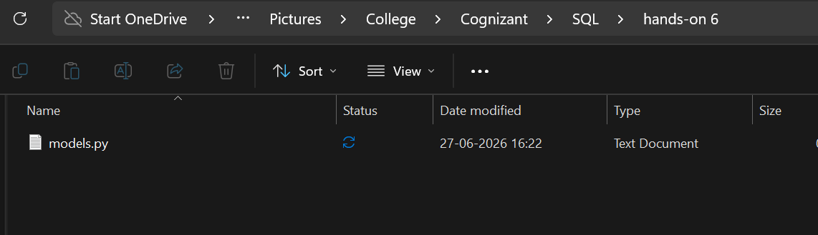
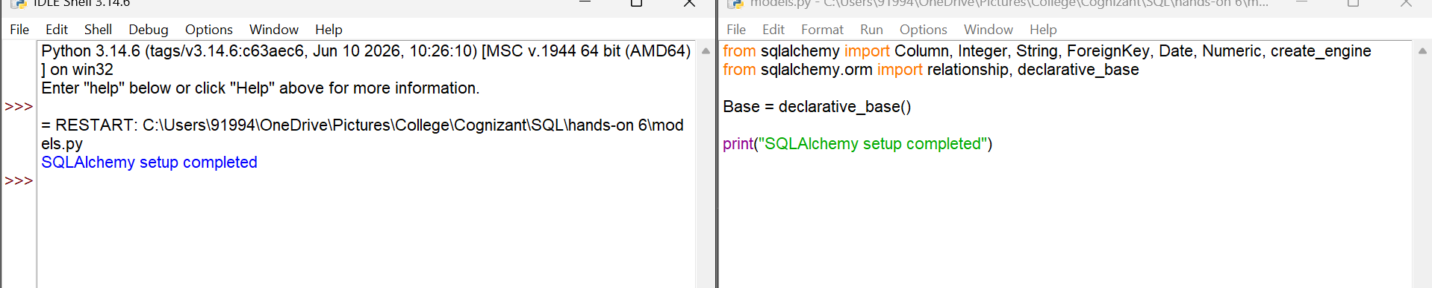

76. Define an engine connecting to your college_db PostgreSQL (or MySQL) database
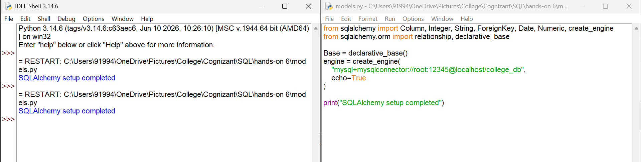

77. Define five ORM model classes: Department, Student, Course, Enrollment, Professor — mapping to the same columns as your SQL schema.
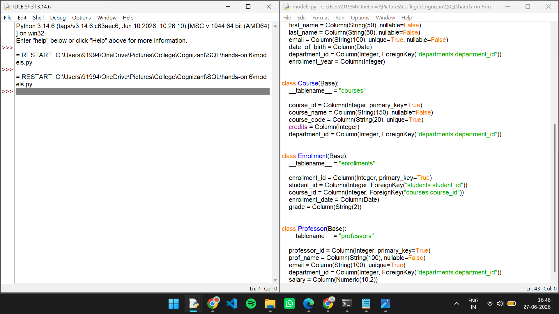

78. Define relationships: Student has a many-to-one relationship to Department. Enrollment has many-to one relationships to both Student and Course.
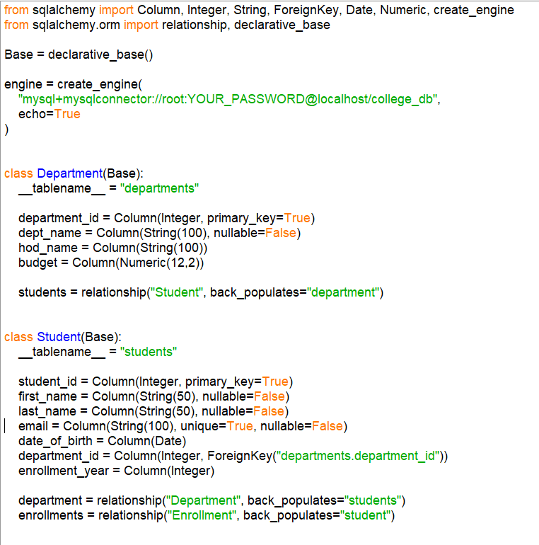

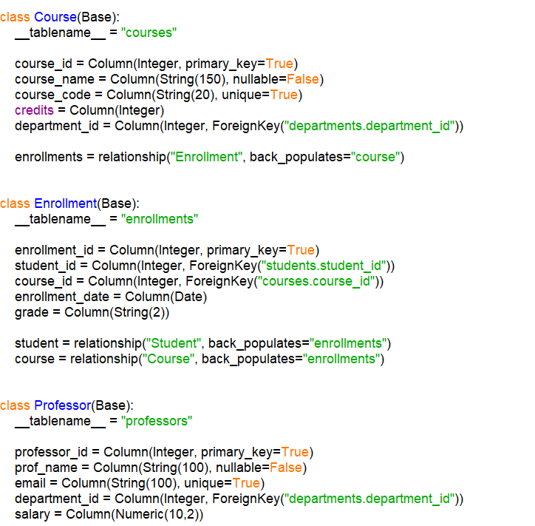

79. Use Base.metadata.create_all(engine) to auto-create tables in a fresh database (college_db_orm), and confirm they appear in your SQL client.
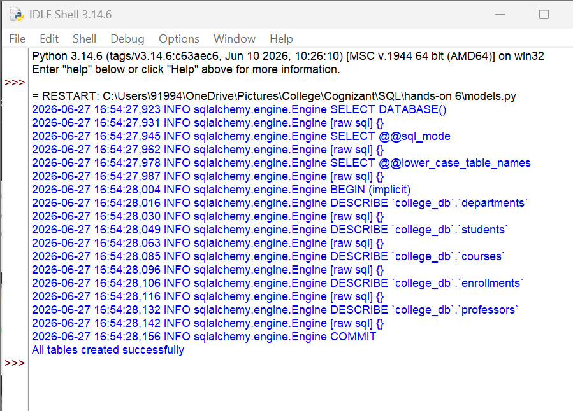

Task 2: CRUD Operations via ORM
Goal: Perform all CRUD operations using SQLAlchemy's session API.
Steps:
80. Create a crud.py file. Open a Session using sessionmaker.

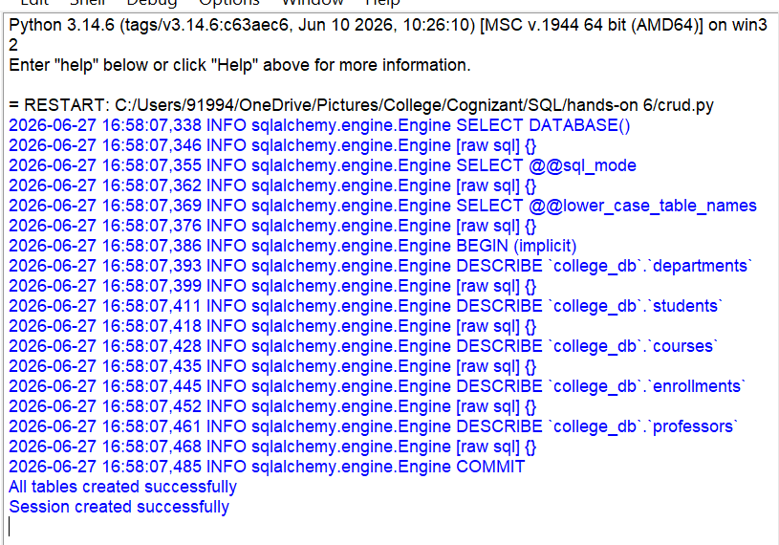

81. INSERT: Add 3 Department objects and 5 Student objects. Commit the session.
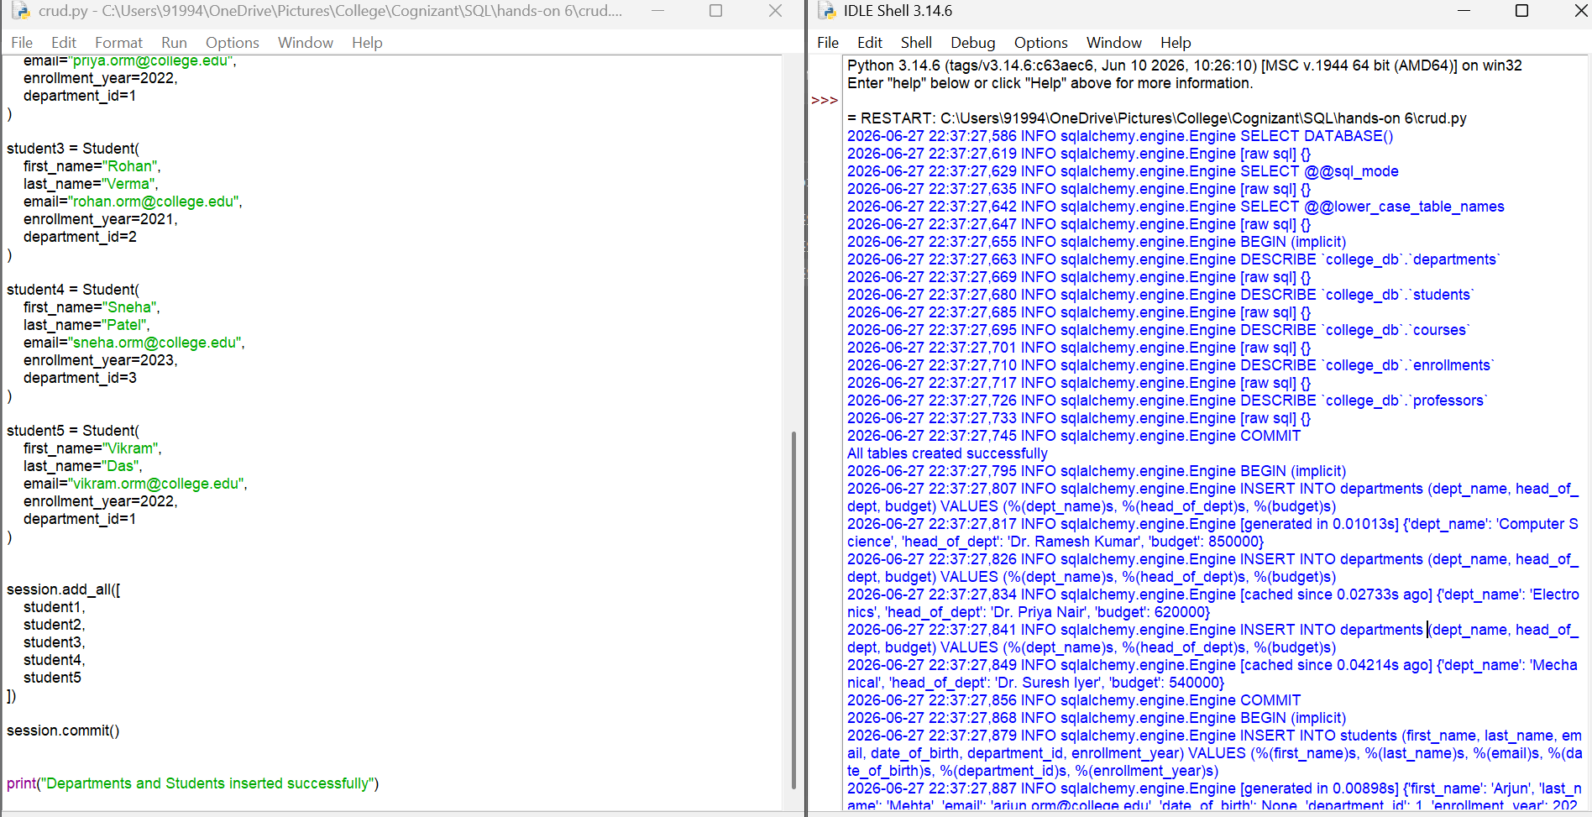

82. INSERT: Add 3 Course objects and 4 Enrollment objects linking students to courses
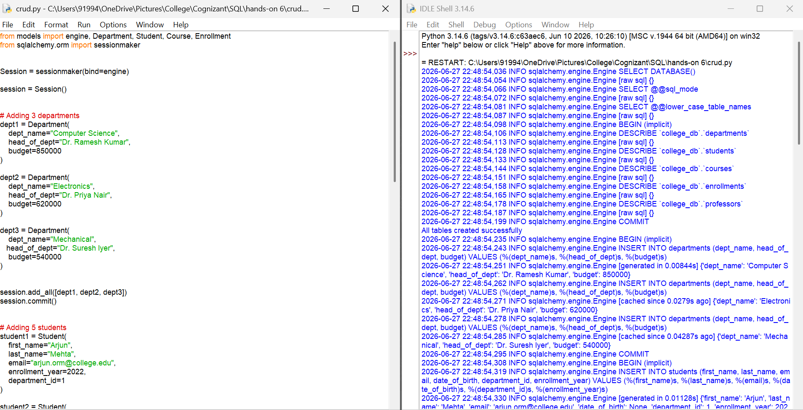

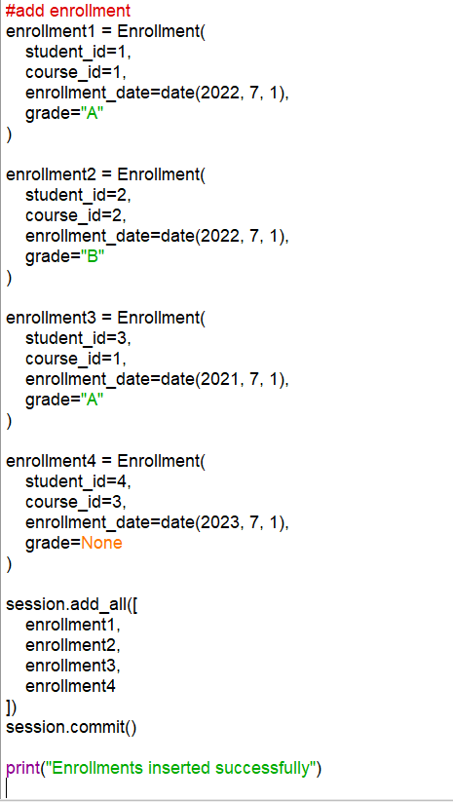

83. READ: Query all students in department 'Computer Science' using session.query(Student).join(Department).filter(Department.dept_name == 'Computer Science').
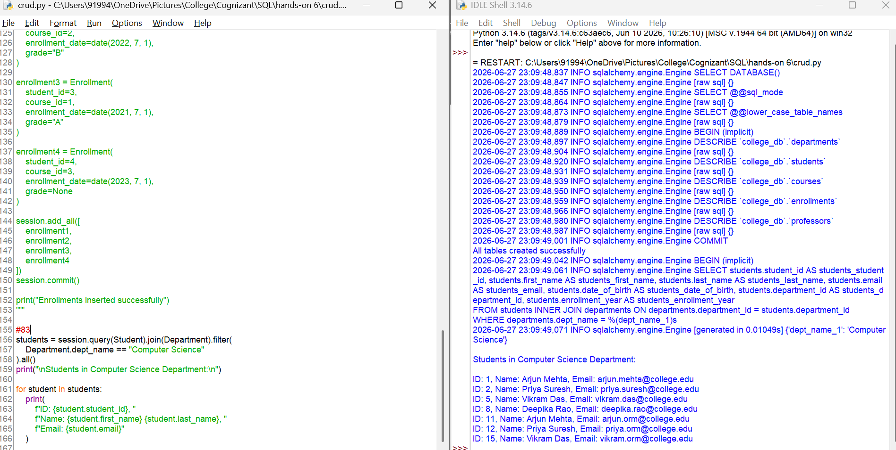

84. READ: Query all enrollments and print each student's name alongside course name. Enable echo=True on the engine to count SQL queries issued.
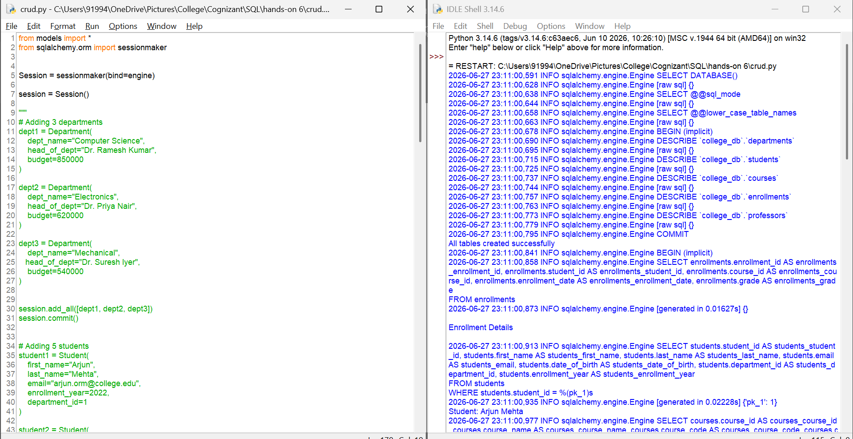
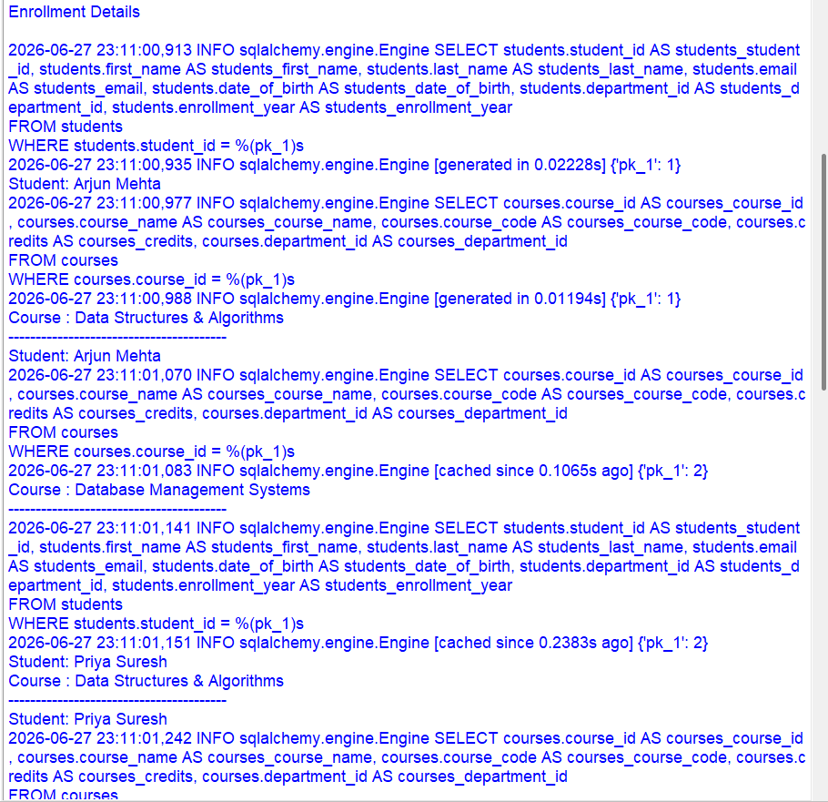

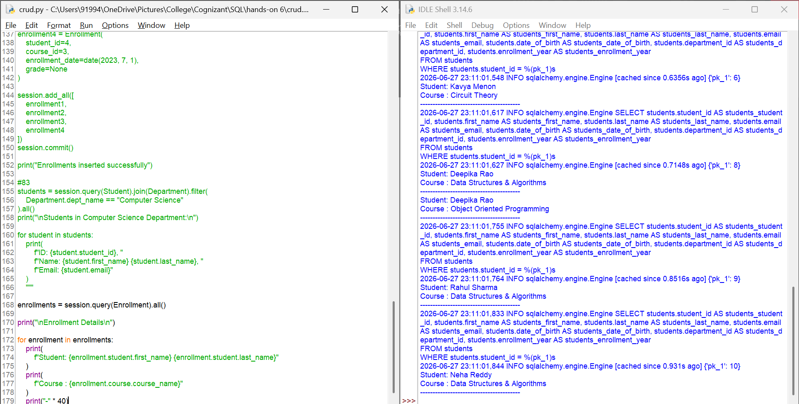

85. UPDATE: Find a specific student by email and update their enrollment_year. Commit.
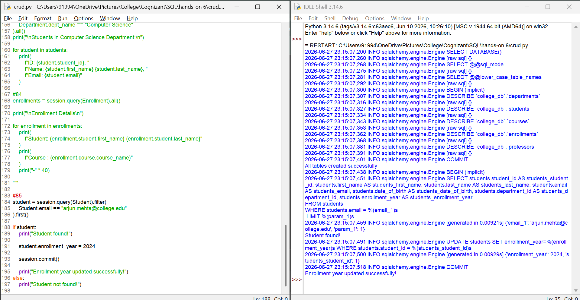

86. DELETE: Remove an enrollment record using session.delete(enrollment_obj). Commit and verify
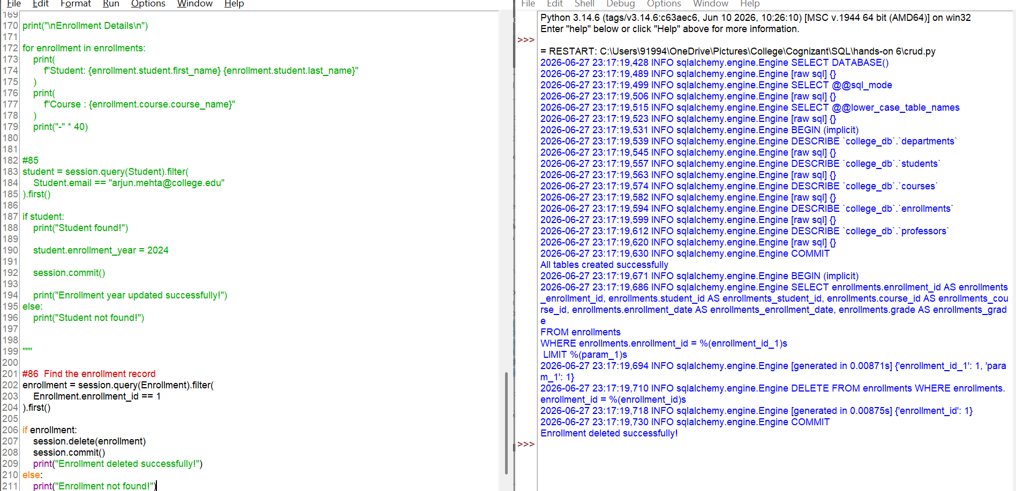

Task 3: Eager Loading to Fix N+1 Goal: Use joinedload to eliminate N+1 queries in ORM code. Steps:

87. Identify the N+1 query from Task 2 Step 5 by counting the SQL log lines with echo=True.
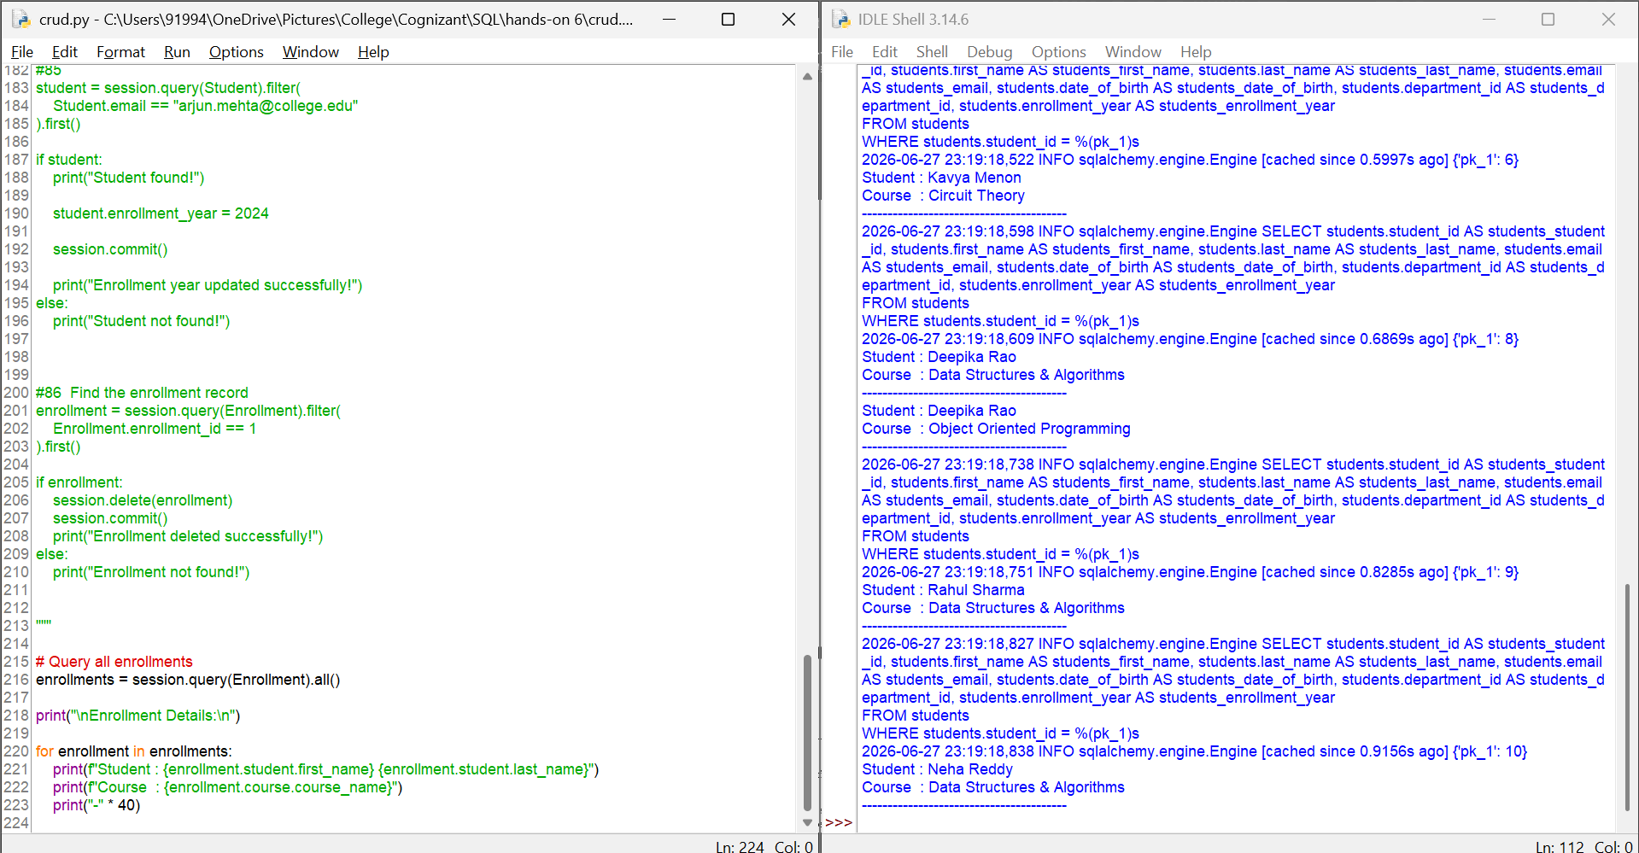

88. Rewrite the query using joinedload: from sqlalchemy.orm import joinedload session.query(Enrollment).options(joinedload(Enrollment.student), joinedload(Enrollment.course)).all()
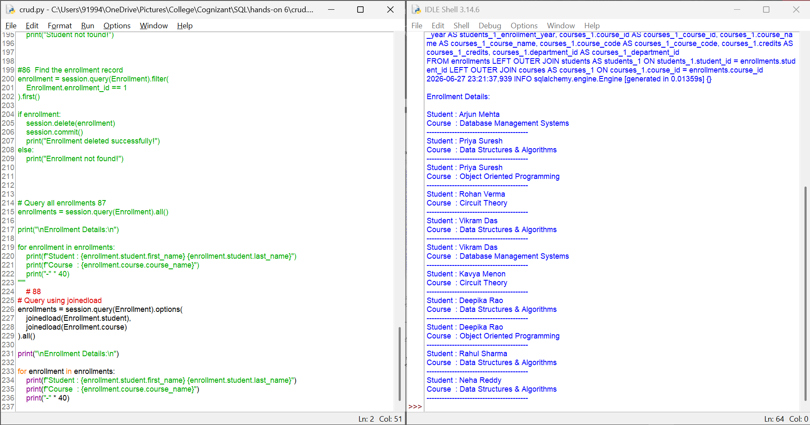

89. Count the SQL queries again with echo=True — it should now be 1 query (or 3 using the subquery loading strategy).
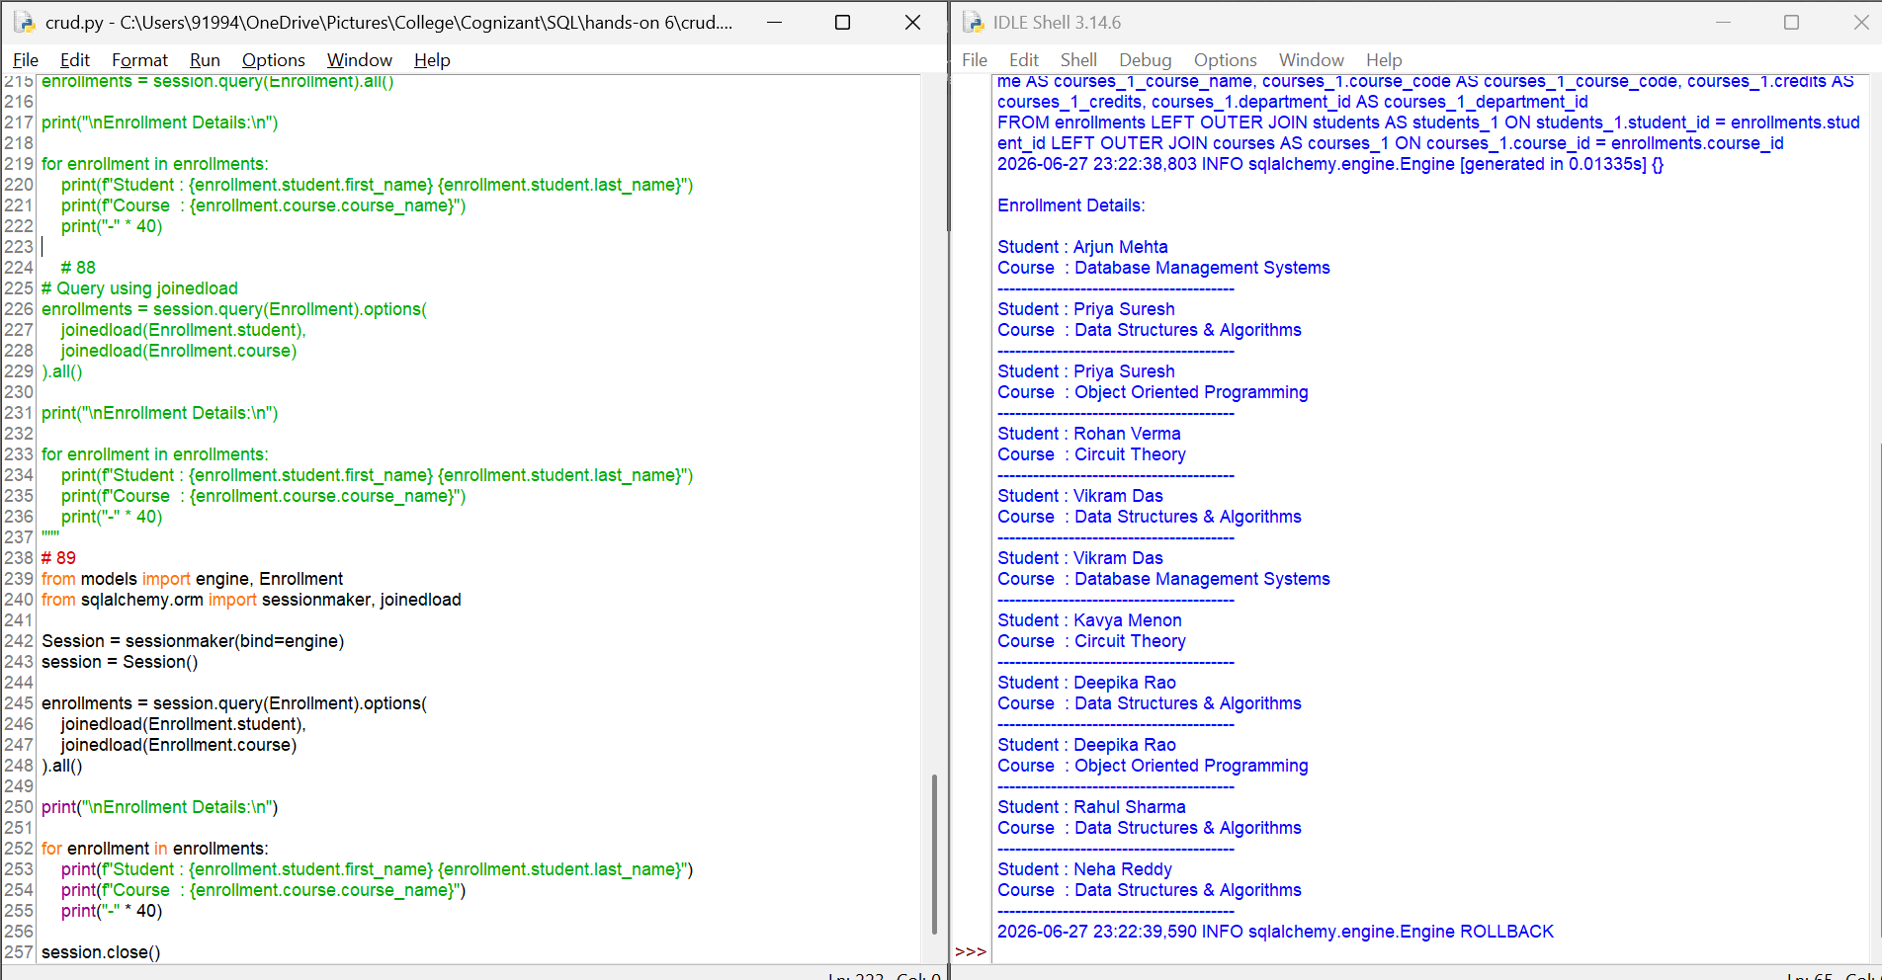
90. Compare the two outputs and document the difference in a comment block at the top of crud.py.
